CADD140B
Assessment TESTS
SLO#1
- 1- Given a basic size of .50 inches and a fit of RC8, calculate the limits for both the hole and the shaft.
- 2- Given a basic size of .50 inches and a fit of RC8, calculate the limits for both the hole and the shaft.
- 3- Find the limits, tolerance, type of fit, and type of system for a F30 H11/c11 fit.
- 4- Find the limits, tolerance, type of fit, and type of system for a F30 P7/h6 fit.
- 5- What is the tolerance accumulation for the distance between surface A and B for the following three dimensioning methods?
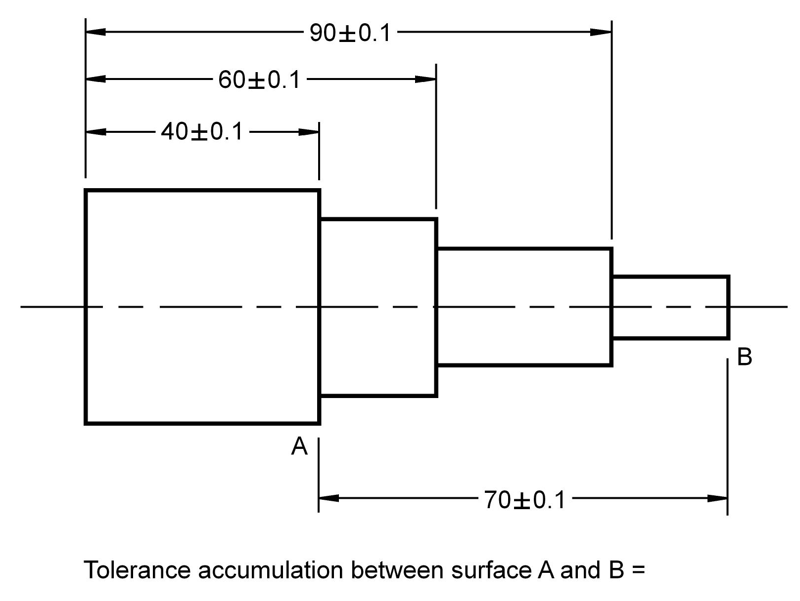
- 6- If the accuracy of the distance between surface A and B is important, which dimensioning method should be used?

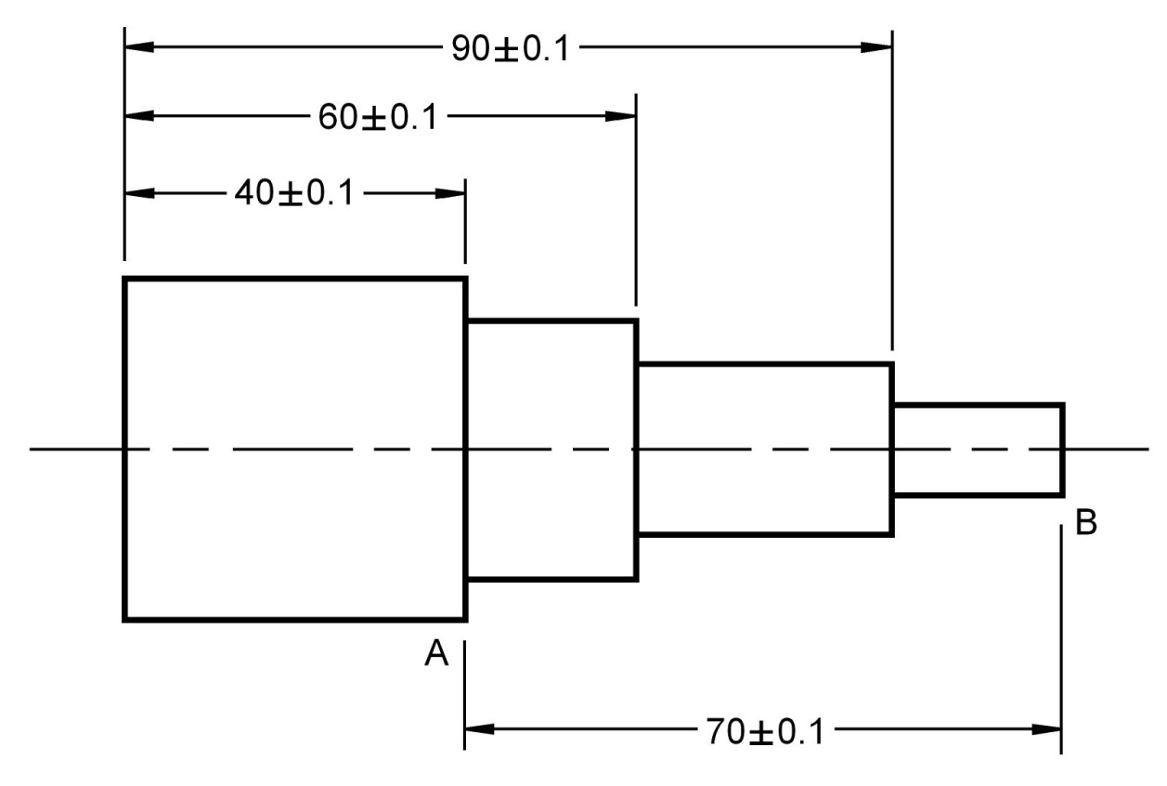
- 7- Assuming that the diameter dimensions are correct, explain why this object is dimensioned incorrectly.
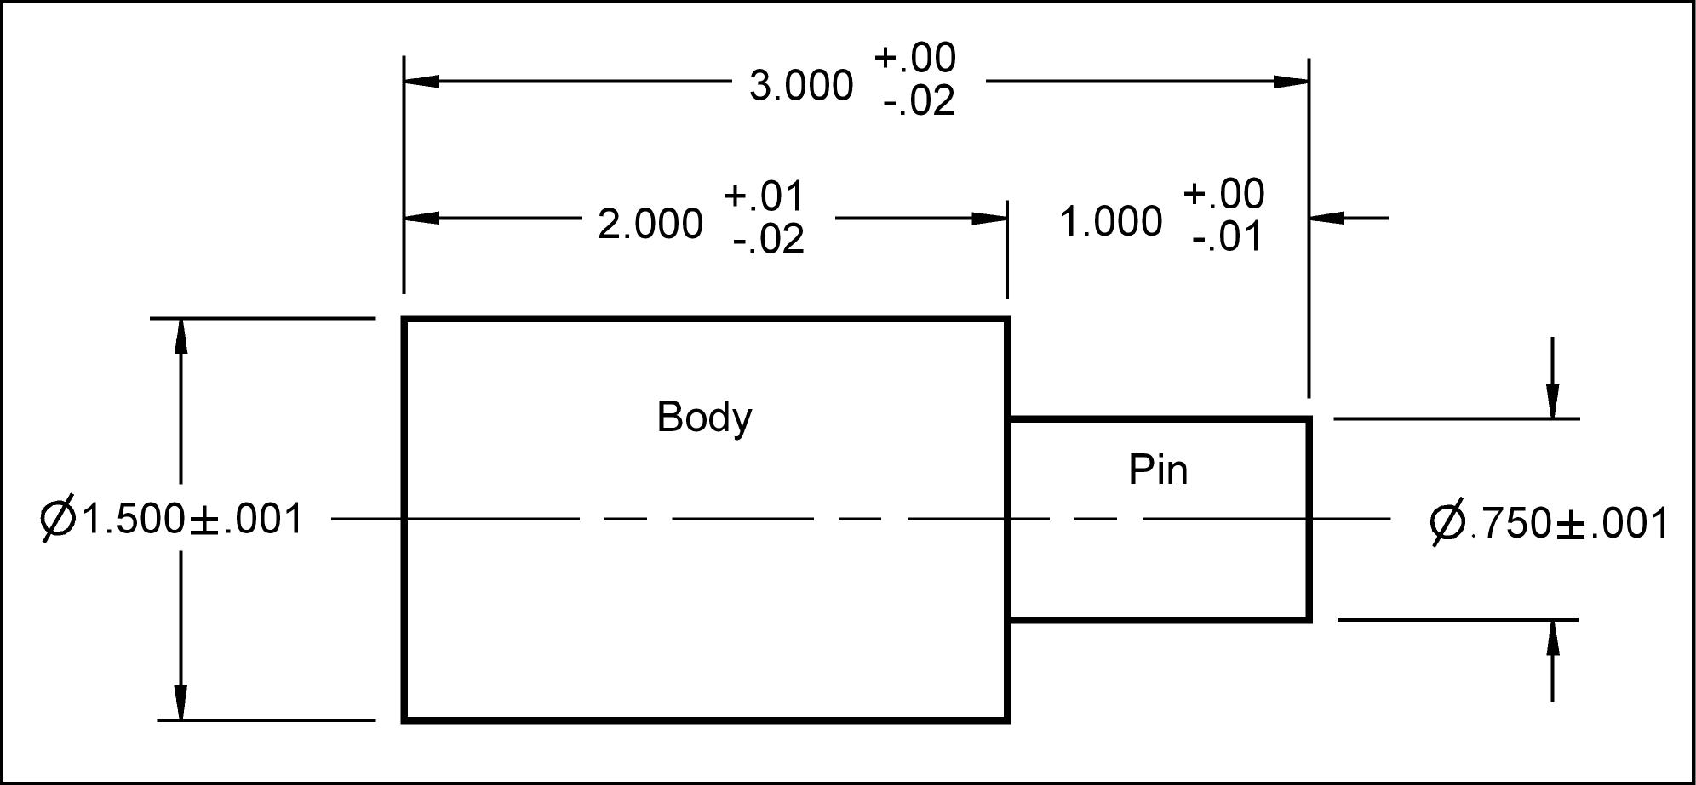
SLO#2
- 1- Identify the Major, Minor & Pitch diameters and the Thread Depth
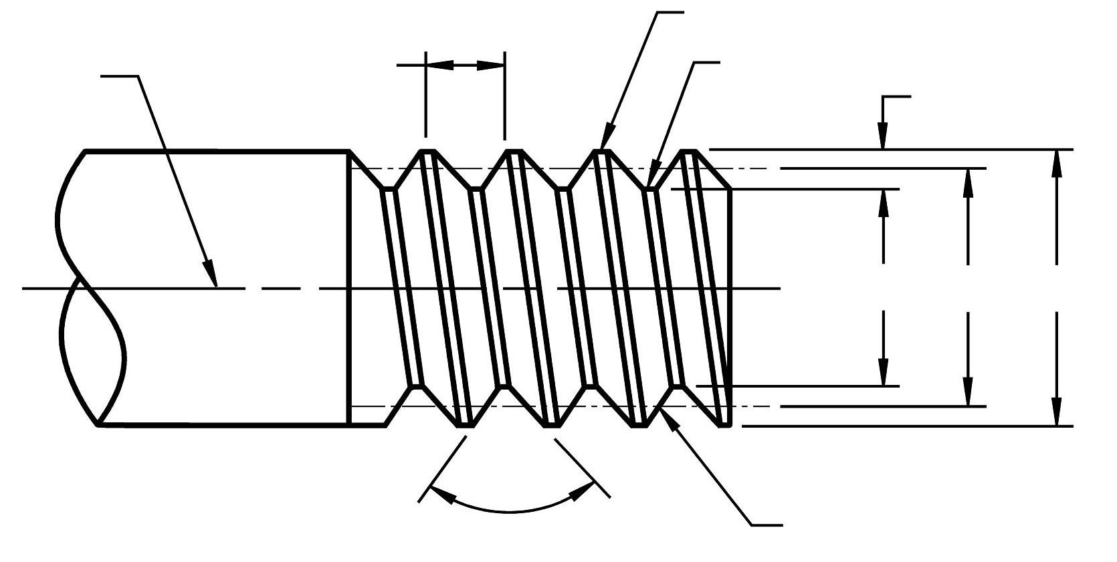
- 2- Identify the different components of the following Unified National thread note.
1/4 – 20 UNC – 2A – RH

- 3- Write the thread note for a #10 fine thread.

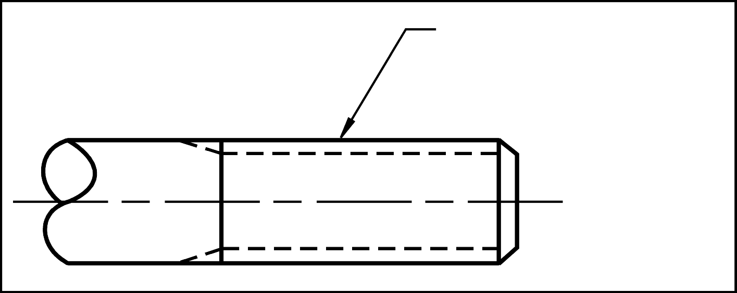

- 4- Identify the different components of the following metric thread notes. M10 x 1.5 – 4h6h – RH
- 5- For a F16 internal metric thread. Which has the finer thread?
Pitch = 2
Pitch = 1.5
- 6- Write the thread note for a 16 mm diameter coarse thread
- 7- What is the normal fit clearance hole diameter for the following nominal bolt sizes.
Nominal size | Clearance hole
1/4
3/4

- 8- A 5/16 - 18 UNC – Socket Head Cap Screw needs to go through a piece of metal in order to screw into a plate below. The head of the screw should be flush with the surface.
Fill in the following table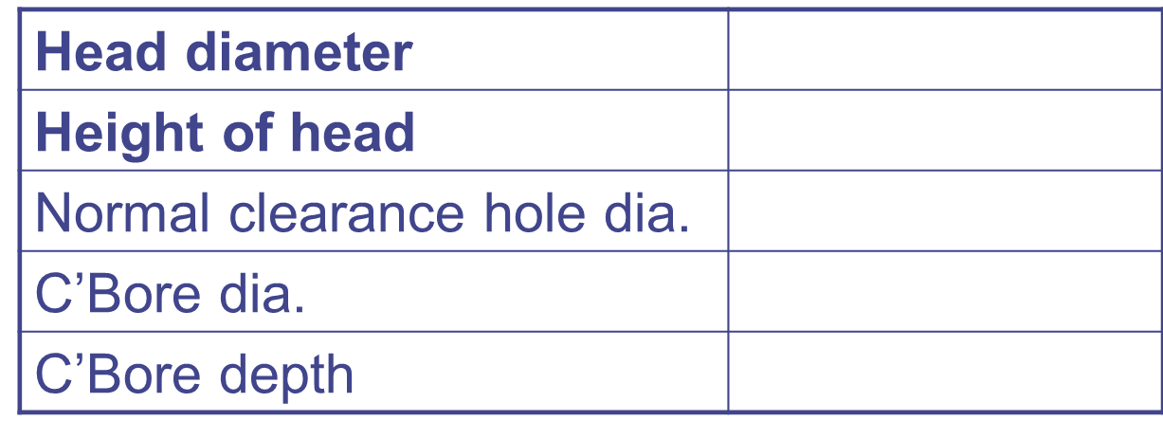
- 9- A 5/16 - 18 UNC – Socket Head Cap Screw
Fill in the following table
Max. Head diameter
Max. Height of head
Normal clearance hole dia.
C’Bore dia.
C’Bore depth

- 10- An M8x1.25 Flat Countersunk Head Metric Cap Screw needs to go through a piece of metal in order to screw into a plate below. The clearance hole needs to be close and the head needs to be flush with the surface. What should the countersink diameter and clearance hole diameter be?
SLO#3
- 1- Fill in the section line is the largest area.
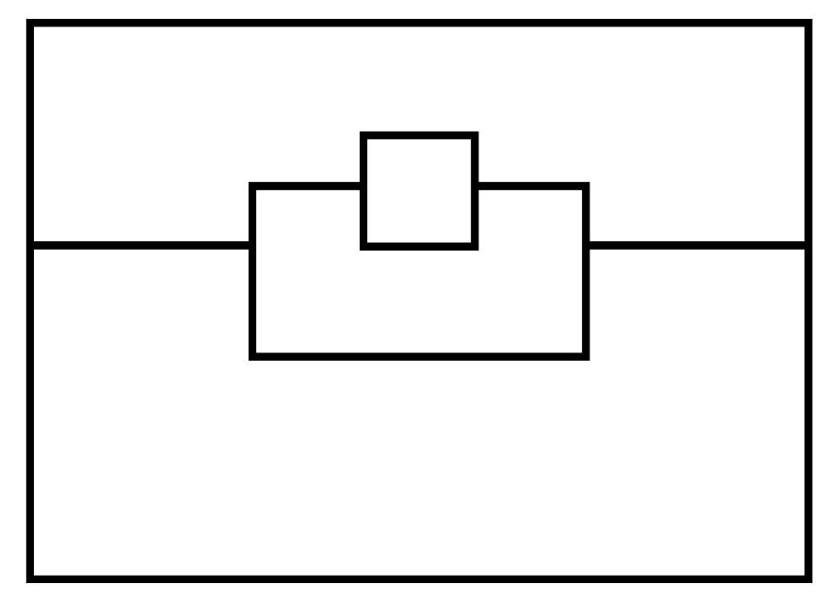
- 2- Draw an assembly drawing of the Clamp shown. Draw detailed drawings of the individual parts. Create a standard parts sheet.
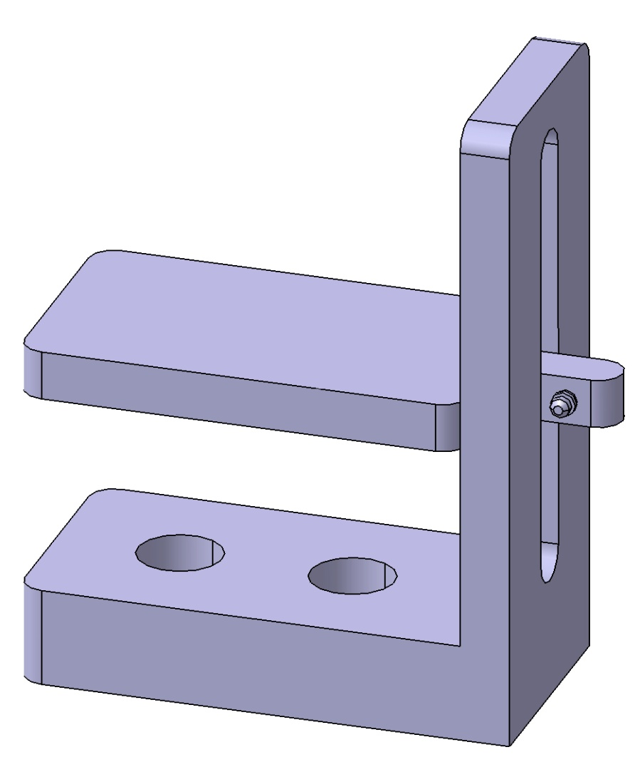
- 3- Create an isometric pictorial of the following object.
- 4- Create a full scale isometric pictorial of the following object. The grid spacing is 10 mm.

